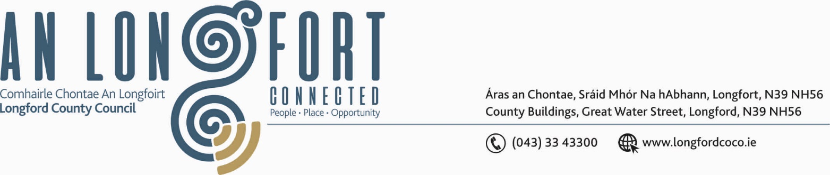

2u Deireadh Fomhair 2019.

Chuig: Gach Ball don Chomhairle.

A Chomhairleoir,

Iarrtar ort bheith i láthair ag Cruinniú Chomhairle Chontae Longfoirt a tionólfar i Seomra na Comhairle, Aras an Chontae, Longfoirt ar an Chéadaoin, 9u Deireadh Fomhair 2019 ag 3.00 p.m. chun gnó a dhéanamh d’réir an Chláir thíos.
You are requested to attend Meeting of Longford County Council to be held in the Council Chamber, Aras an Chontae, Great Water Street, Longford, on Wednesday, 9th October 2019 at 3.00 p.m to transact business, as set out on the Agenda hereunder.

Mise le meas,


_______________
Anne Lee,
Meetings Administrator.

C L A R

Prayer before Meeting.

- Confirmation of Minutes of Meeting of Longford County Council held on the
11th September 2019 - enclosed.

- Matters arising from Minutes.

3. Declaration of Interest by Members.

4. To note Management Report - to follow.

5. To note adopted Minutes of Corporate Policy Group Meeting held on
10th July 2019 – copy enclosed.
6. Finance & Regeneration.

(a) Consideration of Overdraft Accommodation of €5.5m for year ending 31st December 2020.

7. Strategic Infrastructure and Climate Change.

- To note Planning Applications received since last meeting of the Council.

- Consideration and adoption of Part 8 Report (Planning and Development Act 2000 (as amended) and Planning and Development Regulations 2001) (as amended) in respect of the construction of 1 no. 1 bed single storey house at Fair Green, Longford – details attached.

- Consideration and adoption of Part 8 Report (Planning and Development Act 2000 (as amended) and Planning and Development Regulations 2001) (as amended) in respect of 1 no. 4 Bed Single Storey Dwelling at Cloonahard, Co. Longford – details attached.

- Consideration and adoption of Five Year Traveller Accommodation Plan – enclosed.

- Notices of Motions submitted by Councillors, as listed hereunder –
Councillor Micheal Carrigy.
I call on the OPW to provide funding similar to the Local Improvement Scheme to clean the various small rivers throughout the county.
Councillor Joe Flaherty.
“That Longford County Council calls on the Minister for Communications, Climate Action and the Environment to publish, before the end of the year, the cross-governmental Clean Air Strategy and introduce a prohibition on the sale, distribution and burning of smoky coal all across County Longford as soon as possible.”

8. Community, Corporate and Enterprise.

- Preparation of Register of Electors.

- Consideration of Draft Heritage Plan 2019 – 2024 - Draft enclosed

- (i) Appointment of Ms. Emma Kiernan, Ms. Pat Murphy, Ms Angela Keaveny and
Ms Ndidi Idehen to represent Longford Public Participation Network on the Longford Joint Policing Committee.

(ii) Appointment of Ms. Niamh Donlon to represent the business community in Longford on the Longford Joint Policing Committee.

- Appointment of Ms. Francesca Pawelczyk, nominee of Longford Public Participation Network
to replace Mr. Ray Hogan as a member of Longford Local Community Development
Committee (LCDC).

- Civic Reception to recognise Sporting Achievement at National and International level.

9. General

- Notices of Motion, submitted by Councillors, as listed hereunder –

Councillor Seamus Butler.

“That Longford County Council abhors the violent criminal activity that has beset the County for the last six months. We call on Garda Commissioner Drew Harris to ensure that sufficient resources and personnel are deployed to prevent further despicable crimes and that current investigations lead to timely arrests and arraignments of the perpetrators. It is also requested that sufficient personnel resources are provided for permanent foot/bicycle daily patrols to be instigated, in order to restore and reassure the people of Longford that they are safe in their homes and environs.”

Councillor Micheal Carrigy.
“I call on the Minister for Finance to provide extra funding in the Health budget to provide the extra Home help hours that are needed to care for the elderly on the waiting list.”

- Correspondence – enclosed.

- Letter dated 30th September 2019 regarding availability of Spinraza Drug.

10. Training -
Consideration of Report from Corporate Policy Group.

11. Votes of sympathy.

